Hi Jim,
Beverly (Clowning Around) said you do the 'Web Site' thing... So here is the INFO:
~~~
Doyle said we should 'put together' what needs to be 'POSTED' on Renninger's Site about the MAIN Show with all 12 Highwaymen Artists Showing and Selling at the Donnelly Building in Mount Dora on August 14 & 15.
~~~~~~~~~~~~~~~~~~~~~~~~~~~~~~~~~~~~~~~~~~~~~~~~~~~~~~~~~~~~~~~~~~~~~~~~~~~~~~~~~~~~~~~~~~~~~~~~~~~~~~~
This is what currently exists:

Vintage Highwaymen Paintings Show & Sale at
Renninger's Antiques Center Mt. Dora, Florida
August 14th & 15th
A special exhibit and sale at
Renninger's Antiques Center will
feature Highwaymen Paintings
recently de-accesses from two of
the Orange County History Centers
traveling exhibits along with
published pieces from three
Highwaymen Books. More than 60
Vintage Highwaymen Paintings that
have not been available until this
event. Prices range from $400.00
to $9,000.00.
Paintings Presented by:
Harold Newton, Sam Newton, George
Buckner, Alfred Hair, Al Black,
James Gibson, Mary Ann Carroll,
Rodney Demps, Roy McLendon,
Livingston, Roberts, Willie Daniels,
Johnny Daniels, Hezikiah, Baker,
Robert Butler.
~~~~~~~~~~~~~~~~~~~~~~~~~~~~~~~~~~~~~~~~~~~~~~~~~~~~~~~~~~~~~~~~~~~~~~~~~~~~~~~
PLEASE ADD from the following:
Here is the INFO about the 12 Artist's 5th HIGHWAYMEN ART Show and Sale in MOUNT DORA:
This is What will REALLY BRING people to Mount Dora... AND Renninger's the Weekend of August 14 & 15
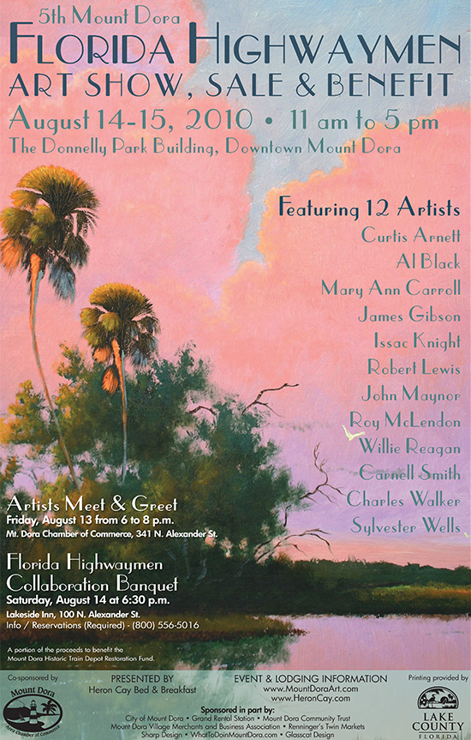
** NOTE: Under "Sponsored in part by:" -- Renninger's Twin Markets **
12 Original Florida Highwaymen Artists return to Downtown Mount Dora for their 5th Show & Sale at the Donnelly Building... August 14th & 15th:
Curtis Arnett - Al Black - Mary Ann Carroll - James Gibson - Issac Knight - Robert Lewis - John Maynor - Roy McLendon - Willie Reagan - Carnell Smith - Charles Walker (1st Time here) - Sylvester Wells.

During the First 2 weeks of August, experience the art of the famous FLORIDA HIGHWAYMEN on the Highwayman Art Walk. 24 Downtown Businesses will display Paintings by one of the Artists (only) attending the MAIN Show on August 14 & 15. The Art Walk officially begins on Friday, July 30th and runs through Friday, August 13th. This WALK includes 2 Weekends... when You (Renninger's) will be OPEN!!
~~
Friday, August 13th, the evening prior to the Main Saturday and Sunday events, the Mount Dora Chamber of Commerce will host a ‘Meet and Greet’ the Artists between 6 and 8 p.m. at the Chamber’s Historic Train Station. Refreshments and light appetizers will be served. Admission is FREE… and ALL are invited to attend.
~~
On Saturday, August 14th, take part in a One-of-a-Kind opportunity to dine with the 12 Florida Highwaymen Artists at the fabulous Beauclaire Restaurant at the Lakeside Inn while they finish an original 'Collaborate' painting during dinner. One lucky attendee will be taking the painting home as a door prize!
~~
More DETAILS... http://www.whattodoinmtdora.com/activities/highwaymen/mountdoraart.shtml
Thanks For your HELP !!!
If you have any questions... please call ANYTIME at 383-4050.
Best,
Randy / HERON CAY Lakeview Bed & Breakfast INN

